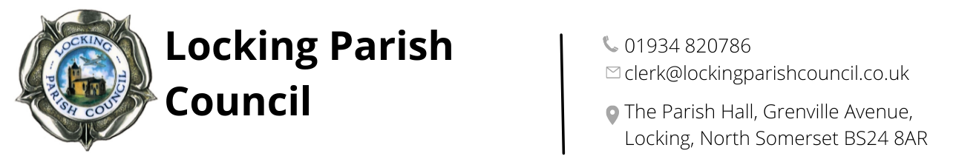 | Locking Parish Council   admin@lockingparishcouncil.gov.uk   01934 820786   The Parish Hall, Grenville Avenue, Locking, BS24 8AR
Locking Parish Hall Booking Form – Safeguarding Procedures
Locking Parish Council has a Policy for Safeguarding Children, Young People and Vulnerable Adults. A copy is attached. Your booking agreement is conditional upon you complying with it unless you, or the organisation you represent, already have an equivalent policy of your own.
You are required to ensure that children, young people and vulnerable adults are protected at all times, by taking all reasonable steps to prevent injury, illness, loss or damage occurring; and that you carry valid personal liability insurance for this.
In particular this means that:
- you will comply with the attached LPC Safeguarding Policy for safeguarding children and young people or vulnerable adults unless you already have an equivalent: https:www.lockingpc.co.uk
- you will provide the Parish Council with a copy of your organisation’s Safeguarding Policy or if you do not have one adopt the current Locking Parish Council policy;
- you will recruit safely all current paid and voluntary workers who work with children and/or vulnerable adults, by obtaining satisfactory disclosures from the Disclosure and Barring Service where eligible, and keeping records of dates and disclosure numbers indefinitely;
- you will keep a list of the names of all paid and voluntary workers with regular and direct contact with children/vulnerable adults, and update it annually;
- you will always have at least two leaders over the age of 18 years in any group of children and young people, no matter how small the group;
- no person under the age of 18 years will be left in charge of any children or young people of any age;
- no child or group of children or young people should be left unattended at any time;
- a register of children, young people or vulnerable adults attending the activity will be kept securely. This will include details of their name, contact details of parent/guardian/carer etc., date of birth and next of kin;
- you will immediately (within 24 hours) inform the Clerk of:
- the occurrence of any incidents or allegations of abuse or causes of concern relating to members or leaders of your organisation, and contact details for the person in your organisation who is dealing with it
- any known offenders against children or vulnerable adults seeking to join your membership, and manage such allegations or agreements with offenders in co-operation with statutory agencies, and with Locking Parish Council.

Locking Parish Clerk is: Dawn Tremlett E-mail: clerk@lockingparishcouncil.gov.uk Tel. No: 01934 820786

Declaration

I agree to abide by appropriate safeguarding procedures. I understand that my booking agreement may be terminated in the event of my failing to comply with these procedures.

Signed ……………………………………………………………………………. Print Name: ………………………………………………..

Organisation ………………………………………..………………………………... Date ……………………………………………..…………

Please sign two copies, one to be retained by Locking Parish Council, and one by the organisation/individual

